**TYPE:** Test

**TASK 2: Cells, Tissues and Metabolism Test (78 marks)**

Students will complete a number of questions relating to cells, tissues and metabolism. These questions will address specific content as well as analysis of second-hand data. This task will be completed in one session under test conditions.

**Time for the tasks (1 hour)**

* 5 minutes reading time
* 55 minutes working time

**What you need to do:**

* Follow the instructions provided very carefully to complete the test.
* Draw any results in pencil and answer all questions given.
* It is your responsibility to organise your time effectively.
* There is to be no discussion between you or any of your class mates.
* No sharing of any equipment or answers at all.

|  |  |
| --- | --- |
| **Requirements for assessment** | **Date** |
| * Complete all questions | _**__________________** |

|  |  |  |  |
| --- | --- | --- | --- |
| **Section** | **Type of question** | **Marks Available** | **Your Mark** |
| **1.** | **Multiple Choice** | **18** |  |
| **2.** | **Short Answer** | **50** |  |
| **3.** | **Extended Response** | **10** |  |
|  | **TOTAL** | **78** | /78 |
|  |  |  | % |

**DO NOT TURN THIS PAGE OVER UNTIL YOU ARE TOLD TO**

**STUDENT NAME: __________________________________________________________________**

**TEACHER: Ms Burns**

**YEAR: 11**

Cells Tissues & Metabolism Test

**PART A: Multiple choice questions (23 marks)**

Please mark your answers on the answer sheet provided.

1. Energy for the cell’s use is released in the form of

a. heat

b. bADP

c. ATP

d. DNA

1. The process by which a substance spreads from an area of high concentration to an area of low

concentration is known as

a. pinocytosis

b. osmosis

c. active transport

d. diffusion

1. Enzymes are:

a. organic catalysts

b. consumed in chemical reactions

c. needed for all chemical reactions

d. organic reactants

1. All cells obtain energy for their general metabolic activity by the oxidation of glucose. This basic process is known as cellular

a. reproduction

b. respiration

c. photosynthesis

d. metabolism

Enzyme Activity

1 2 3 4 5 6 7

pH

The above enzyme is active in the stomach. What is the optimum pH (acidity) for this enzyme?

a. neutral – pH 7

b. acidic – pH 4

c. basic

d. pH 5

1. Active transport occurs when the substances move across membranes:

a. from lower to higher concentrations

b. from higher to lower concentrations

c. by osmosis

d. by simple diffusion

1. A protein is made up of:

a. simple sugars

b. fatty acids

c glycerol

d. amino acids

1. A student wanted to investigate the relationship between cell size and the rate at which substances enter cells. For this investigation he cut potato into cubes of 3 sizes: cube 1 was 5 mm3, cube 2 was

10 mm3, and cube 3 was 20 mm3. The cubes were covered in iodine for 5 minutes, after which they were removed and cut in half. Which cube had the smallest surface area to volume ratio?

a. Cube 1

b. Cube 2

c. Cube 3

d. None, as iodine is too large to enter the cell.

1. A student set up an experiment with a semipermeable membrane. The membrane was not permeable to sucrose (a sugar). At the beginning of the experiment the same amount of water was added to both sides of the membrane. The student than added sucrose to the left side of the membrane as shown in the following diagram.

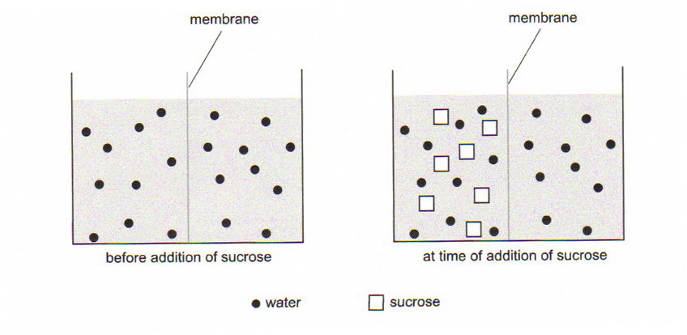

You would expect:

a. the level of water to rise on the left of the membrane

b. the level of water to rise on the right of the membrane

c. the level of water to remain unchanged on both sides of the membrane

d. the concentration of sucrose to increase on the right side of the membrane

1. The organic nutrient with the highest energy value is:

a. sugar

b. starch

c. fat

d. protein

1. Four students were asked to design a first-hand investigation to determine the effect of pH on the activity of an enzyme. Their investigation designs are shown in the tables below.

Key: E=enzyme S=substrate

|  |  |  |  |  |  |  |  |  |
| --- | --- | --- | --- | --- | --- | --- | --- | --- |
| DESIGN A | | | |  | DESIGN B | | | |
| TUBE # | CONTENTS | pH | TEMP (OC) |  | TUBE # | CONTENTS | pH | TEMP (OC) |
| 1 | E | 3 | 20 |  | 1 | E + S | 3 | 20 |
| 2 | E | 7 | 20 |  | 2 | E + S | 7 | 20 |
| 3 | E | 12 | 20 |  | 3 | E + S | 12 | 20 |
| 4 | S | 3 | 20 |  | 4 | S | 3 | 20 |
| 5 | S | 7 | 20 |  | 5 | S | 7 | 20 |
| 6 | S | 12 | 20 |  | 6 | S | 12 | 20 |

|  |  |  |  |  |  |  |  |  |
| --- | --- | --- | --- | --- | --- | --- | --- | --- |
| DESIGN C | | | |  | DESIGN D | | | |
| TUBE # | CONTENTS | pH | TEMP (OC) |  | TUBE # | CONTENTS | pH | TEMP (OC) |
| 1 | E + S | 3 | 10 |  | 1 | E + S | 7 | 10 |
| 2 | E + S | 7 | 20 |  | 2 | E + S | 7 | 20 |
| 3 | E + S | 12 | 30 |  | 3 | E + S | 7 | 30 |
| 4 | S | 3 | 10 |  | 4 | S | 7 | 10 |
| 5 | S | 7 | 20 |  | 5 | S | 7 | 20 |
| 6 | S | 12 | 30 |  | 6 | S | 7 | 30 |

Which investigation is the most appropriate?

a. design A

b. design B

c. design C

d. design D

1. In facilitated diffusion

a. transport is quicker than normal diffusion

b. transport is selective

c. transport of one substance is stopped by another

d. all of the above

1. Which of the following statements describes the diagram below correctly?

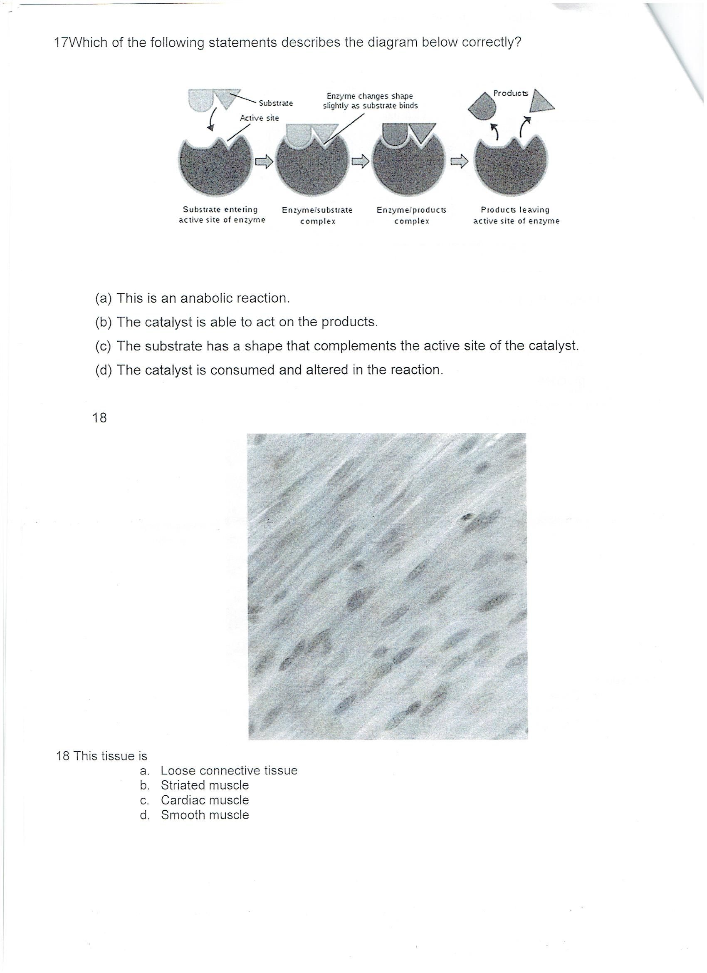

a. This is an anabolic reaction.

b. The catalyst is able to act on the products.

c. The substrate has a shape that complements the active site of the catalyst.

d. The catalyst is consumed and altered in the reaction.

1. Which of the following statements bestdefines osmosis?

a. The movement of water along a concentration gradient, without the expenditure of ATP.

b. The movement of water against a concentration gradient, without the expenditure of ATP.

c. The movement of water against a concentration gradient, through a semi-permeable membrane.

d. The movement of water along a concentration gradient, through a semi-permeable membrane, requiring the expenditure of ATP.

1. The concentration of lactic acid in a muscle is greater after exercise than it is before exercise. This is

because there is;

a. insufficient oxygen in the muscle during exercise.

b. an excess of carbon dioxide in the muscle.

c. insufficient glucose in the muscle.

d. a high rate of aerobic respiration.

1. ATP is essential to every living cell, because it;

a. controls metabolic rate.

b. stores energy released during the breakdown of ADP.

c. stores energy in a form that is readily available.

d. reacts with glucose to form energy.

1. Which of the following does not match the nutrient with its sub-units?

a. Vitamins – made up of minerals

b. Proteins – made up of amino acids

c. Carbohydrates – made up of monosaccharides

d. Lipids – made up of fatty acids and glycerol

1. Which list below correctly has the hierarchy of biological organization?

a. molecules, cells, tissues, organs, systems

b. molecules, cells, tissues, systems, organs

c. cells, organs, tissues, systems,

d. tissues, cells, systems, organs

**END OF MULTIPLE-CHOICE QUESTION SECTION**

**PART B: Short Answer questions. (50 marks)**

Please write your answers in the spaces provided on this sheet

* 1. Write the balanced chemical equation for cellular respiration:

________________________________________________________________________

(1 marks)

* 1. List three reasons cells require energy:

i) ________________________________________________________

ii) ________________________________________________________

iii) ________________________________________________________

(3 marks)

1. The following graph shows the results of an experiment involving the breakdown of starch by an enzyme.

**Effect of temperature on breakdown of starch by an enzyme**

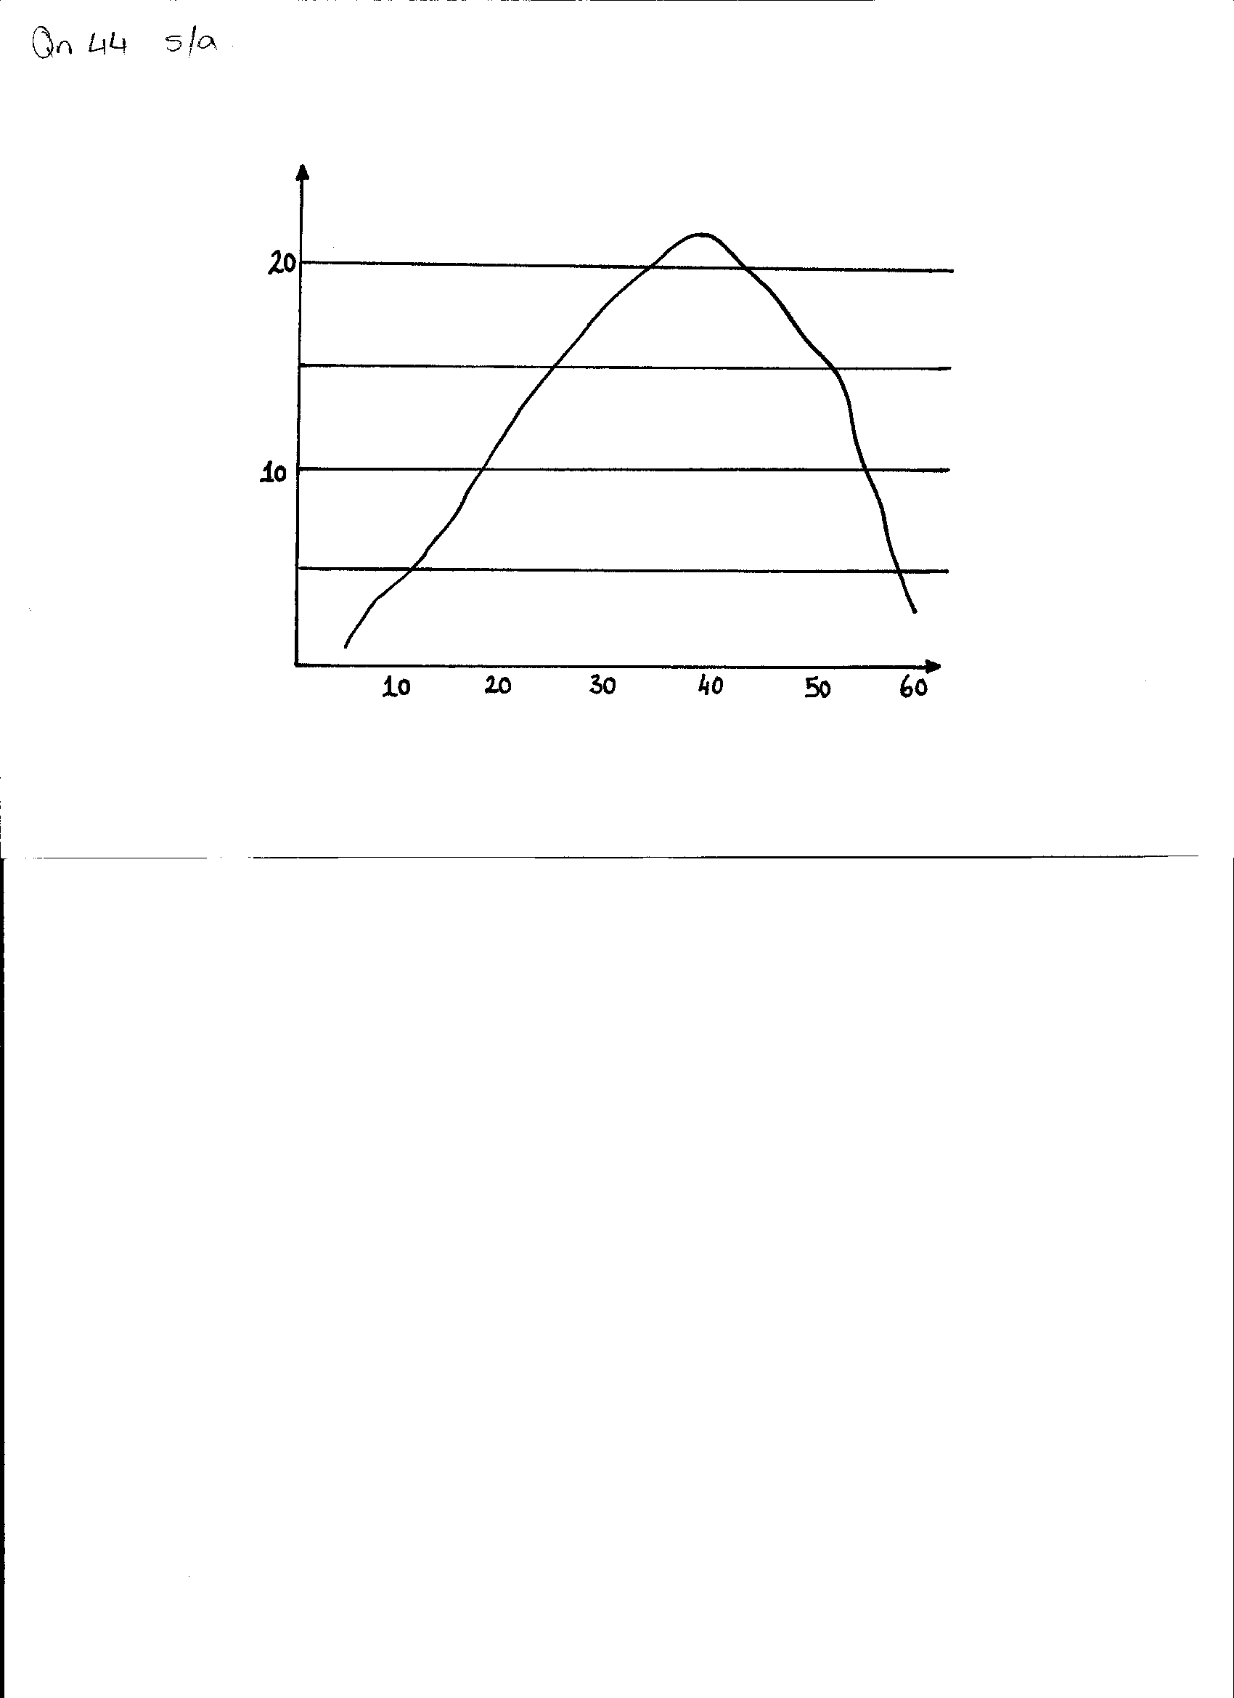

**Enzyme activity in mg of starch broken**

**Temperature in OC**

a. What is the optimum (best) temperature for the activity of this enzyme? (1 mark)

______________________________________________________________________

b. Why does the rate of reaction drop rapidly at body temperatures above 45OC? (1 mark)

____________________________________________________________________________________________________________________________________________________________________

c. What is the end product from the digestion of starch? (1 mark)

______________________________________________________________________

d. Name the substrate of the enzyme lipase. (1 mark)

______________________________________________________________________

e. State **ONE** factor, other than temperature, which affects the activity of an enzyme. (1 mark)

______________________________________________________________________

1. Explain the following processes, where they occur in the cell and the amount of energy each

process yields.

a. Aerobic respiration (3 marks)

_________________________________________________________________________________

_________________________________________________________________________________

_________________________________________________________________________________

_________________________________________________________________________________

b. Anaerobic respiration (3 marks)

_________________________________________________________________________________

_________________________________________________________________________________

_________________________________________________________________________________

_________________________________________________________________________________

1. A student observed changes in a red blood cell which was placed in distilled water. Draw in the boxes below, sketches of what she would have seen at those times.

Normal cell

Cell after 10mins

Cell after 30 mins

[1 mark]

a. What is the name for this process? [1 mark]

________________________________________________________

b. Explain your drawings …Why does the cell change? (4 marks)

________________________________________________________________________________

________________________________________________________________________________

________________________________________________________________________________

________________________________________________________________________________

_________________________________________________________________________________

_________________________________________________________________________________

1. What compounds are synthesised in the human body from the following sub-units: (3 marks)
   * 1. Glucose ____________________________
     2. Amino acids ____________________________
     3. Fatty acids & glycerol ____________________________
2. For each of the following processes, state whether the chemical reactions are anabolic or catabolic

reactions. (3 marks)

1. Protein synthesis _____________________________
2. Aerobic respiration _____________________________
3. Anaerobic respiration _____________________________
   1. Label the structures in the diagram below, by writing the name next to the matching letter in the table.

(8 marks)

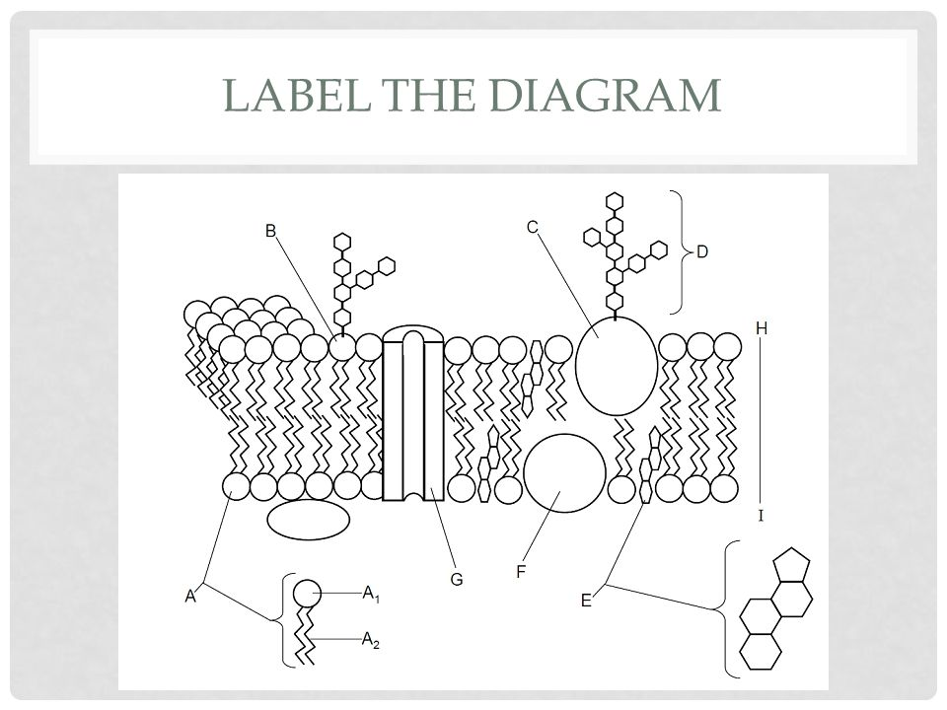

|  |  |
| --- | --- |
| STRUCTURE | NAME |
| A1 |  |
| A2 |  |
| C |  |
| D |  |
| E |  |
| F |  |
| G |  |
| H - I |  |

* 1. What different properties do A1 and A2 have?

________________________________________________________________________________________________________________________________________________________________________________

(2 marks)

* 1. What is the function of structure G?

________________________________________________________________________________________

(1 mark)

1. Vitamin C is essential for the production of collagen in the body. A deficiency in Vitamin C leads to scurvy, a disease that causes loss of teeth and easy bruising, especially around the joints. What role does Vitamin C play in the production of collagen?

__________________________________________________________________________________________________________________________________________________________________________

(2 marks)

1. Draw diagrams to show the process of phagocytosis.

(2 marks)

1. Would you expect the cells of a large mammal like an elephant to be larger than those of a small mammal like a mouse? Explain your answer.

_______________________________________________________________________________________

_______________________________________________________________________________________

_______________________________________________________________________________________

_________________________________________________________________________________________________

(2 marks)

1. Name and describe the levels of structural organisation in the human body.

________________________________________________________________________________________________________________________________________________________________________________________________________________________________________________________________________

_________________________________________________________________________________________________

(6 marks)

**End of Short Answer Questions**

**PART C: Extended Answer questions. (10 marks)**

Please write your answers in the spaces provided on this sheet.

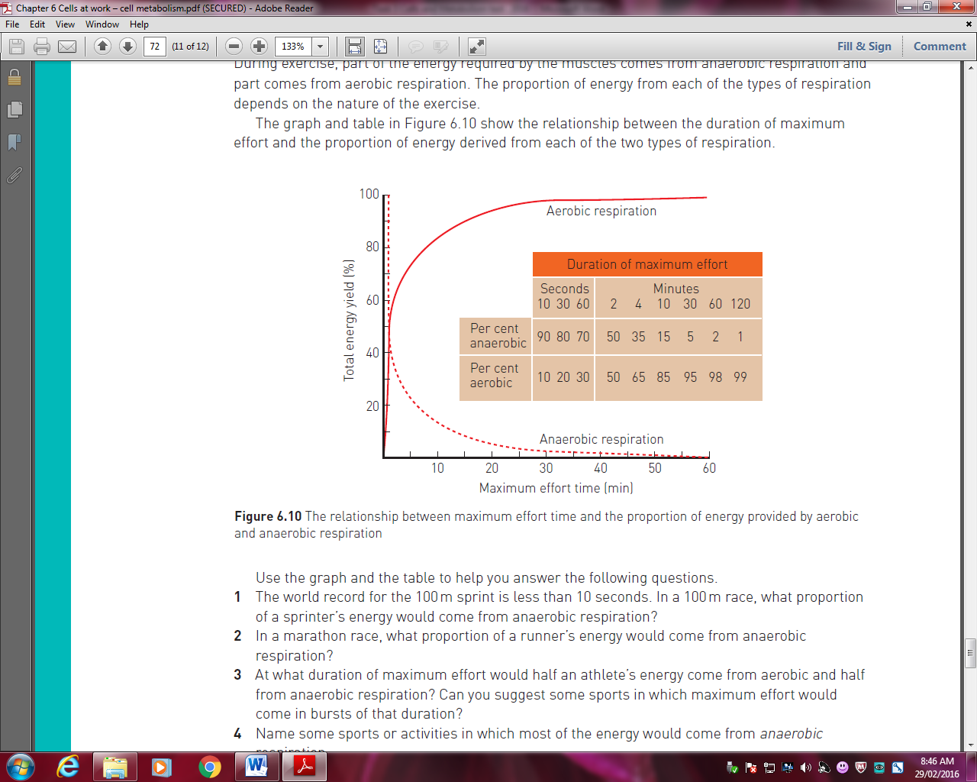10. During exercise, part of the energy required by the muscles comes from anaerobic respiration and part comes from aerobic respiration. The proportion of energy from each of the types of respiration depends on the nature of the exercise. The graph and table below show this relationship.

Using the information above and your knowledge of respiration, explain why some observers noted that a sprinter who had just run 400m in 50 seconds was breathing much more heavily than a runner who had just completed a marathon in 2.5 hours.

________________________________________________________________________________________________________________________________________________________________________________________________________________________________________________________________________________________________________________________________________________________________________________________________________________________________________________________________________________________________________________________________________________________________________________________________________________________________________________________________________________________________________________________________________________________________________________________________________________________________________________________________________________________________________________________________________________________________________________________________________________________________________________________________________________________________________________________________________________________________________________________________________________________________________________________________________________________________________________________________________________________________________________________________________________________________________________________________________________________________________________________________________________________________________________________________________________________________________________________________________________________________________________________________________________________________________________________________________________________________________________________________________________________________________________________________________________________________________________________________________________________________________________________________________________________________________________________________________________________________________________________________________________________________________________________________________________________________________________________________________________________________________________________________________________________________________________________________________________________________________________________________________________________________________________________________________________________________________________________________________________________________________________________________________________________________________________________________________________________________________________________________________________________________________________________________________________________________________________________________________________________________________________________________________________________________________________________________________________________________________________________________________________________________________________________________________________________________________________________________________________________________________________________________________________________________________________________________________________________________________________________________________________________________________________________________________________________________________________________________________________________________________________________________________________________________________________________________________________________________________________________________________________________________________________________________________________________________________________________________________________________________________________________________________________________________________________________________________________________________________________________________________________________________________________________________________________________________________________________________________________________________________________________________________________________________________________________________________________________________________________________________________________________________________________________________________________________________________________________________________________________________________________________________________________________________________________________________________________________________________________________________________________________________________________________________________________________________________________________________________________________________________________________________________________________________________________________________________________________________________________________________________________________________________________________________________________________________________________

END OF TEST